**GAP Analysis Document**

Of

**Hostel module**

For Implementation of

**Campus Management Software**

at

**World Skill Center (WSC)**





**Sustainable Outreach And Universal**

**Leadership (SOUL) Limited**

# 

**Contents**

A. Introduction 2

B. Overview of the document 2

C. List of Screen 3

D. Flow Chart of WSC Hostel 4

A. Hostel 6

1. Masters 6

1.1 Employee Hostel Allotment 6

1.2 Hostel Material 7

2. Student Admission & Essentials 7

2.1 Material Distribution 7

3. Allotment & De-Allotment 7

3.1 Death Deallotment 7

# **Introduction**

The World Skill Center (WSC) is a premier advanced skill training institute established by the Government of Odisha, Skill Development and Technical Education Department, through the Odisha Skill Development Authority (OSDA). The WSC will impart advanced skill training in eight trades from engineering and service sectors. WSC caters primarily to induct the best talent from ITIs and Polytechnics and train them to become globally employable in emerging areas such as "Industry 4.0". WSC is housed in a state-of-the-art, 18-storey, air-conditioned building with nearly half a million square feet of space in the heart of capital city of Bhubaneswar.

With the Implementation of campus management software for WSC the goal is to streamline the operations and functions of the campus by integrating various processes, such as admissions, course registration, academic progress tracking, and financial management, HRMS, Procurement and Inventory management, etc into a unified system. The implementation also aims at providing a user-friendly interface for all stakeholders, making it easier for them to access the necessary information and complete their tasks with ease. The modules to be covered during the implementation of the software includes:

|  |  |
| --- | --- |
| Students Management Modules | Infrastructure Management |
| Academic System | Finance and Accounting System |
| Procurement & Inventory Management | Training and Placement |
| Human Resources Management System | Application Integration |

# **Overview of the Document**

The Gap analysis document is a detailed report that provides an overview of the

gaps between the current state of the project and the desired state, and develop recommendations to close those gaps. Conducting a gap analysis can help us to improve our product and profitability by allowing us to pinpoint “gaps” present in our software. Once it’s complete, we will be able to better focus on our resources and energy on those identified areas in order to improve them.

This document covers all the gaps between the existing software and functional requirements provided by WSC SME’s for Hostel module.

# **List of Screen**

|  |  |  |  |
| --- | --- | --- | --- |
| **SL no** | **Name of the Screens** | **Changes in Existing** | **Is New Screen ?** |
|  | Masters | No | No |
|  | Hostel Masters | No | No |
|  | Student Hostel Admission | No | No |
|  | Employee Hostel Allotment | Yes | No |
|  | Room Allotment | No | No |
|  | Material Distribution | Yes | No |
|  | Hostel Material | Yes | No |
|  | Room Deallotment | No | No |
|  | Room Change | No | No |
|  | Death Deallotment | Yes | No |
|  | Long Leave | No | No |
|  | Inter / Intra Hostel Change | No | No |
|  | Hostel Attendance | No | No |
|  | Student Leave Process | No | No |
|  | Disciplinary Committee Process | No | No |
|  | Hostel Clearance | No | No |

# **Flow Chart of WSC Hostel**

**Hostel Admission Process flowchart**

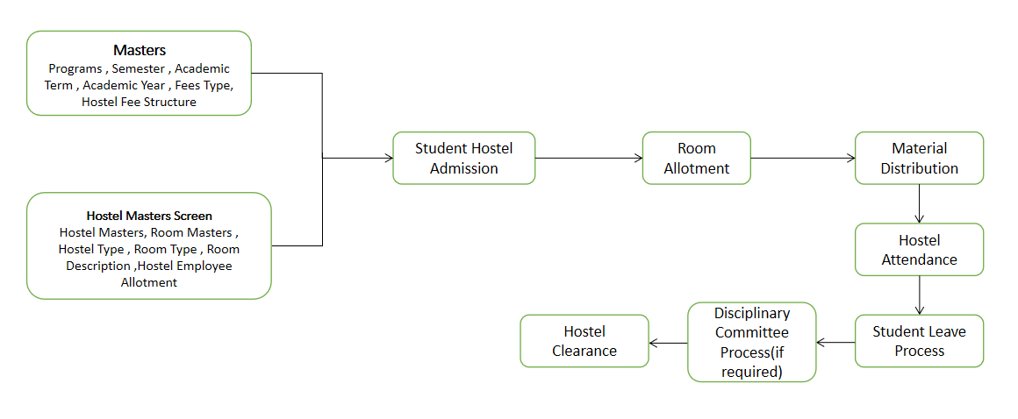

The flowchart depicts the overall flow of WSC Hostel from initial setup to student’s admission in hostel to student’s exit from hostel

**Room Change / Hostel Change Process flowchart**

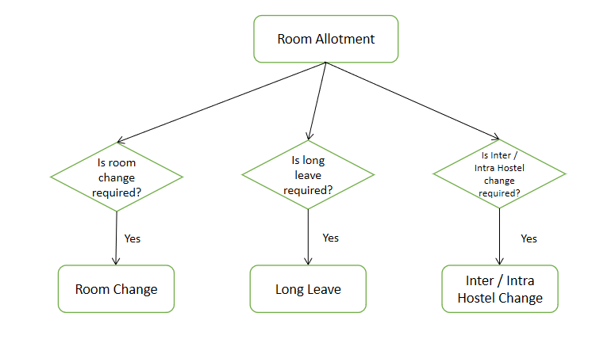

The above flowchart shows the different room and hostel change processes available in the system

**Hostel Fee Process flowchart**

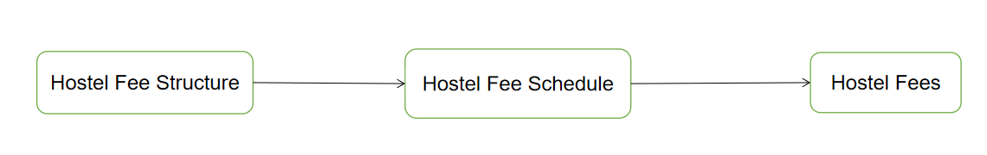

The above flow depicts that the Hostel Fee Structure needs to be determined followed by scheduling of hostel fee which is in turn followed by fee collection.

**Disciplinary Process flowchart**

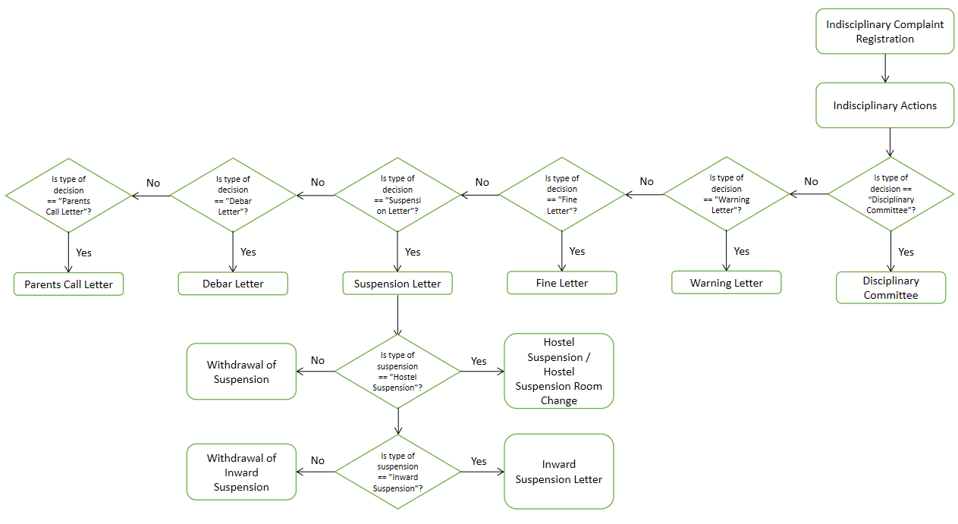

This flowchart shows the Disciplinary Process that can be implemented in the hostel including the formation of a Disciplinary Committee which will take necessary actions against concerned students.

**Room Allotment Process flowchart**

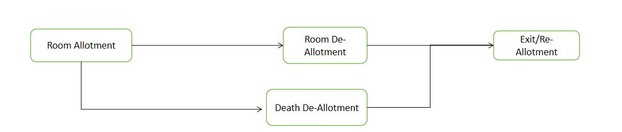

This flowchart shows the two types of de-allotment that is available in the system.

**Hostel Leave Process flowchart**

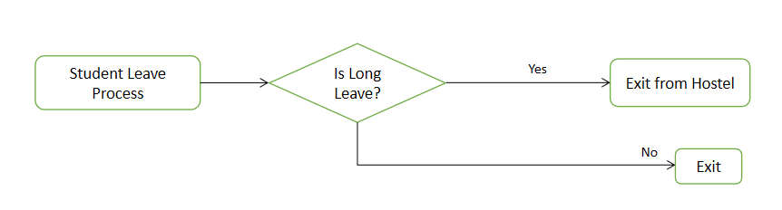

The above flowchart shows the leave process available for hostel residents.

# **A. Hostel**

## **Masters**

### **Employee Hostel Allotment**

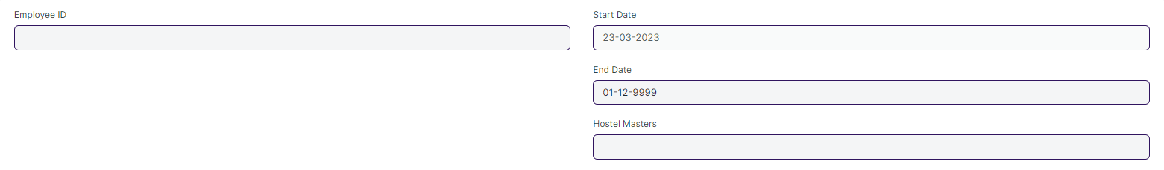

#### **Business Requirement:**

* Designation Field to be added. This field will be auto fetched on selection of employee to distinguish and determine employee designation.

### **Hostel Material**

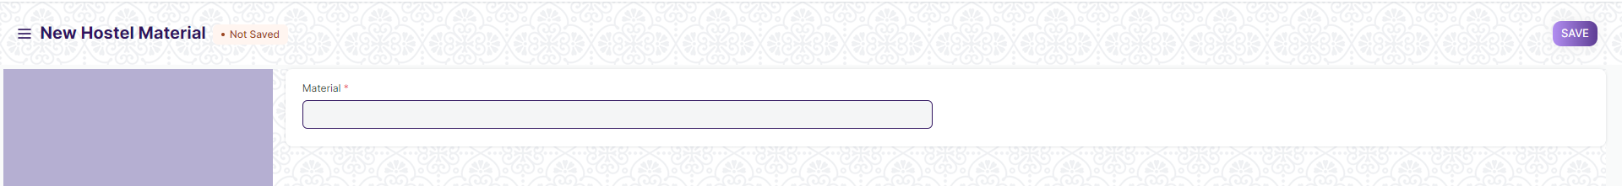

#### **Business Requirement:**

* Hostel Material is master screen where user is going to maintain Material for distribution.
* Data entered in this doctype will be the materials available during Material Distribution.

## **Student Admission & Essentials**

### **Material Distribution**

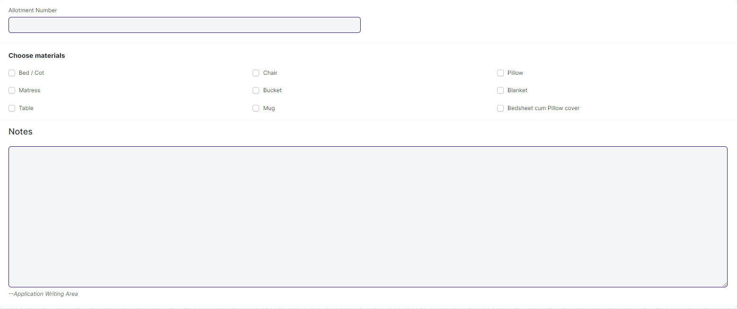

#### **Business Requirement:**

* The preceding page has to be updated to do away with the hard coding of the materials ('Choose materials') and include a child table with a link to the DocType Hostel Material to maximize flexibility. The remainder of the screen will not change.
* Note that the DocType Hostel Material (as shown in Page 6) also has to be developed and is a prerequisite to this requirement.

## **Allotment & De-Allotment**

### **Death Deallotment**

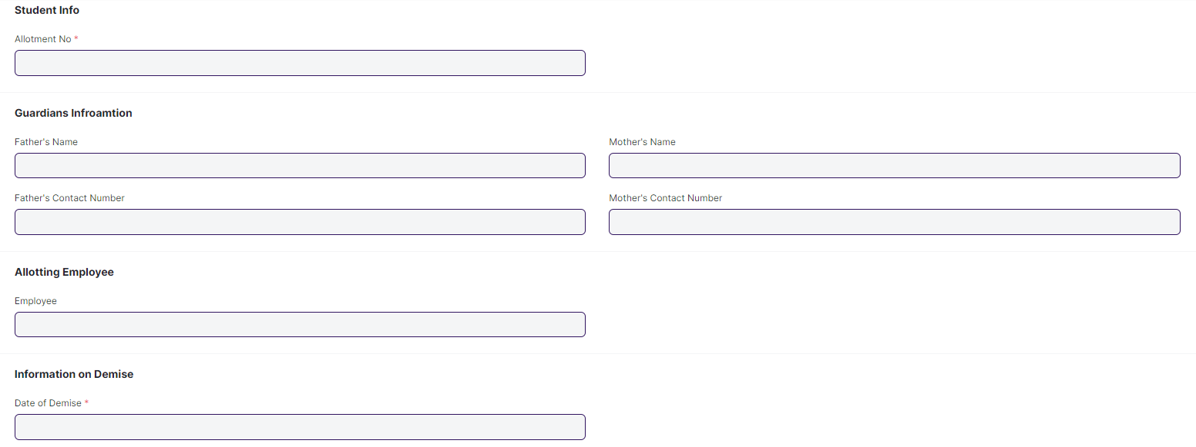

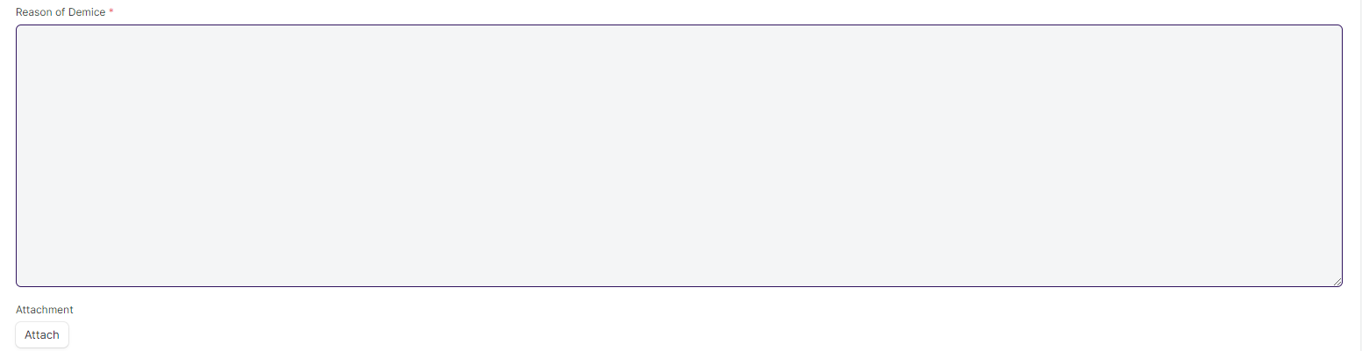

#### **Business Requirement:**

* Rename the DocType to make it more acceptable and standard